|  |
| --- |
| **Argentis Consulting** |
| **Apparel & Footwear** |
| AddOn Install, Uninstall and Upgrade 1.0 |



**www.sapapparel.com**

Contents

1.1 Windows Folders Security Permission 3

1.2 Lightweight Installation Procedure 5

1.2.1 How to install it in the Server 5

1.2.2 How to assign it to a Company 7

1.3 Uninstall and Unassign 10

1.3.1 How to unassign it from the Company 10

1.3.2 How to uninstall it from the Server 10

1.4 Upgrade 11

1.5 Maintenance 12

1.5.1 In the Server Machine 12

1.5.2 In the Server and Client Machines 12

Installation Procedure

In this document you will be able to find how to install and uninstall Apparel in the Server, assign and unassign it to a company, perform an upgrade and also the maintenance required after installing or upgrading Apparel.

## Windows Folders Security Permission

The Addon will need permission to create folders and write files during the installation, upgrade and also when using the different features Apparel & Footwear provides, such us SKUs and Cut Tickets creation. These permissions depend on the Windows User that is logged in.

The default installation path for SAP Business One Client 32 bits is in C:\Program Files (x86)\SAP\SAP Business One\AddOns\ARGNS\Apparel And Footwear. The default installation path for SAP Business One Client 64 bits is in C:\Program Files (x64)\SAP\SAP Business One\AddOns\ARGNS\Apparel And Footwear . However; the folders under the “Program Files” directory have some restrictions to the common Windows Users and Users Group. Unless you manually change the security permissions in the folder under the “ARGNS” directory, you will need to install the AddOn in a directory where the Windows Users are allowed to Read, Execute & Write. For example; you can install the AddOn in the following path C:\ARGNS\Apparel And Footwear.

In case it is decided to install the AddOn in the default path, please verify the Windows Usersx that are going to run the SAP Business One application have the permissions mentioned before.

It is important to remember that every time the AddOn is installed or upgraded, the folder “Apparel & Footwear” and all its subfolders and files are deleted and created again so the permissions might be modified. That is why it is suggested to provide the permissions in the mother folder “ARGNS” (that it is not deleted during an upgrade or re-installation) and also check that inheritance is enabled.

Security permissions for “ARGNS” should look like the following screenshots:

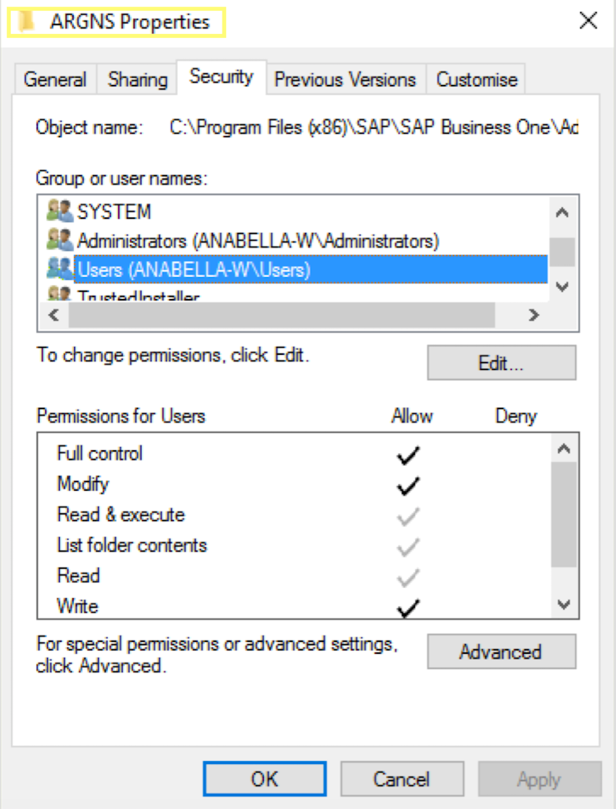

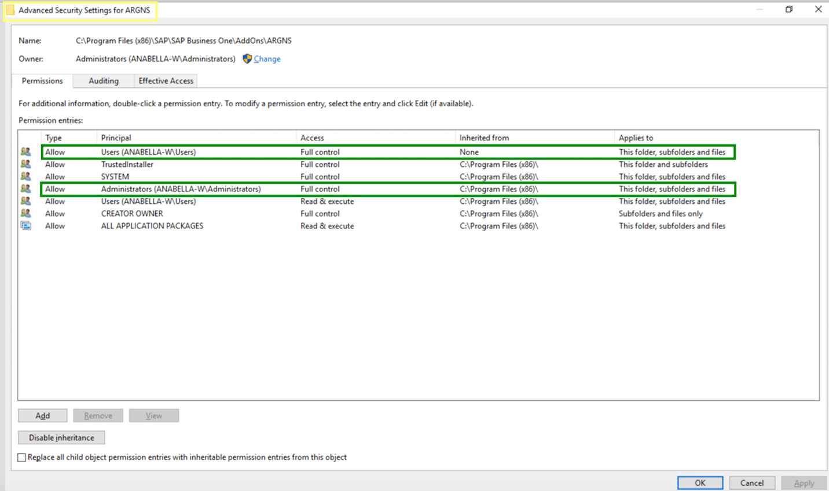

Security permissions for “Apparel And Footwear” should look like the following screenshots:

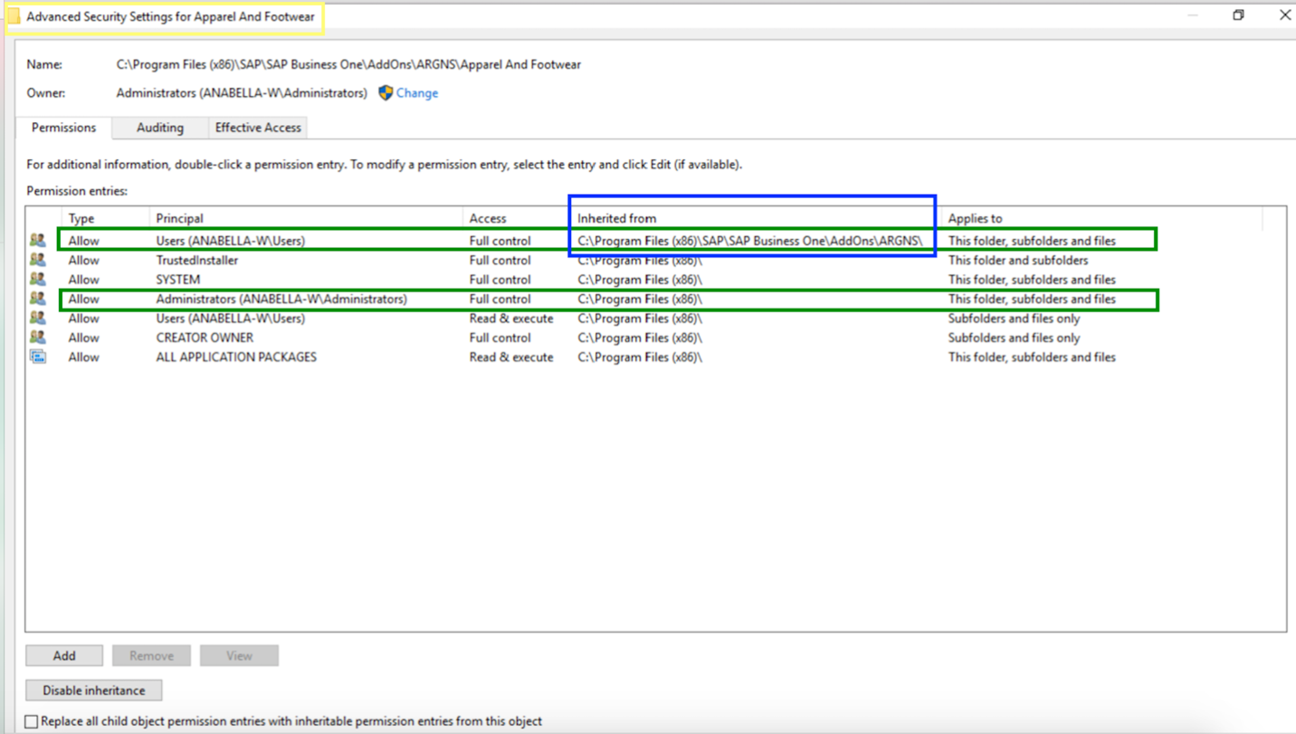

## Lightweight Installation Procedure

### How to install it in the Server

To install the AddOn through the lightweight method, go to AddOn Administration→Manage Extensions for Lightweight Deployment.

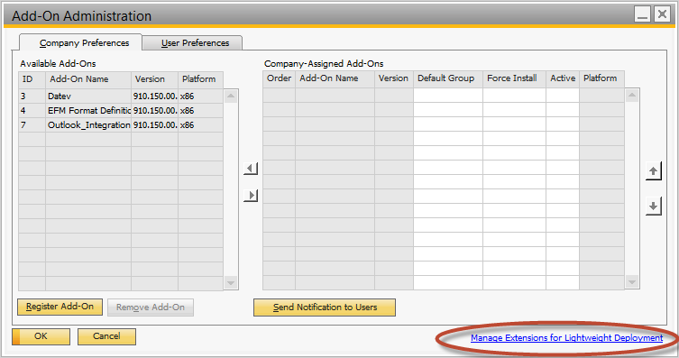

Enter the B1SiteUser and password to login

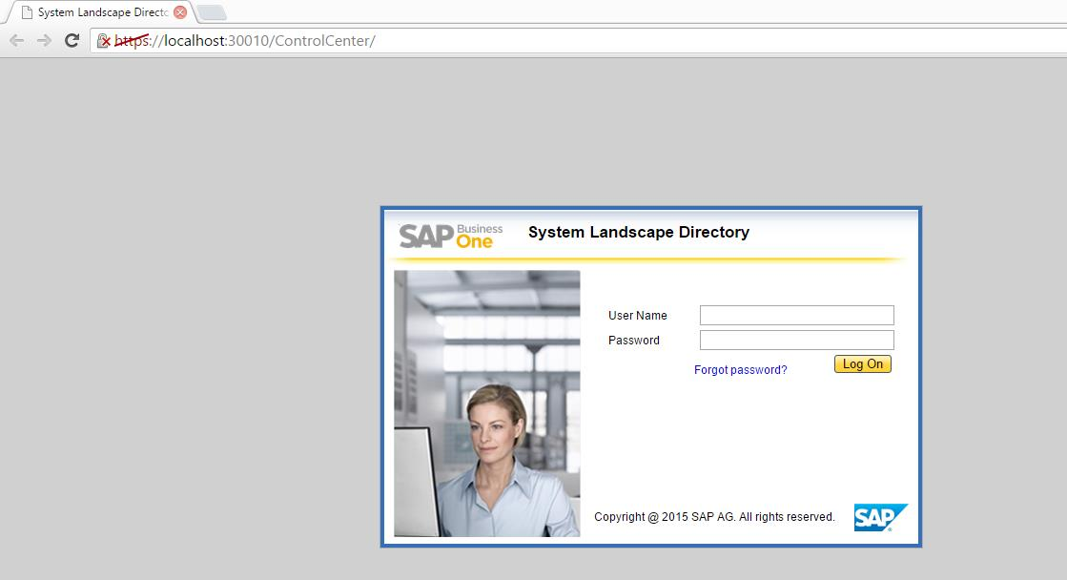

Click on Import and browse the Addon zip file

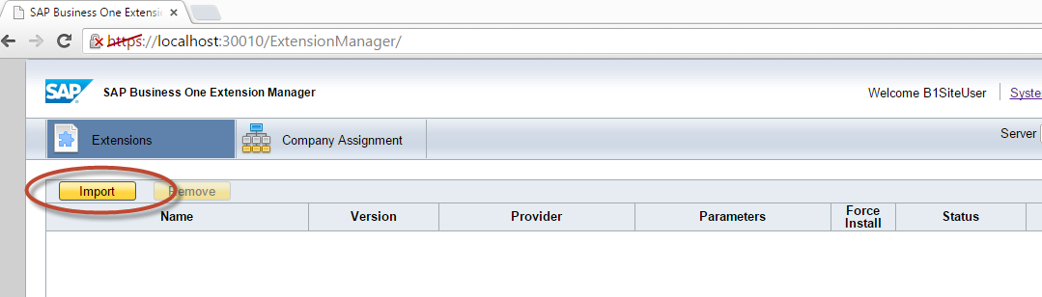

Click on Upload

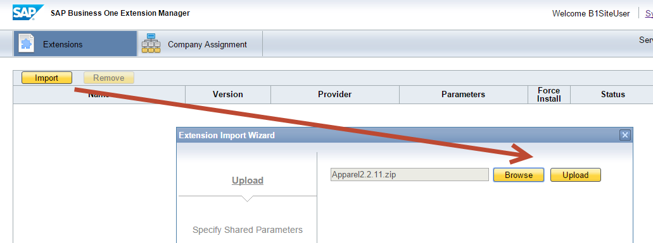

Once the file is uploaded check the status

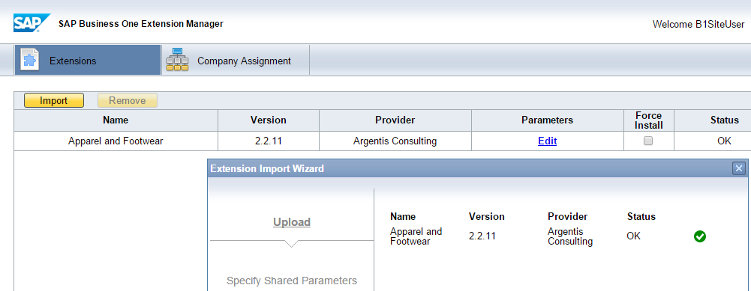

### How to assign it to a Company

Next assign the Addon on to the SAP Company Database

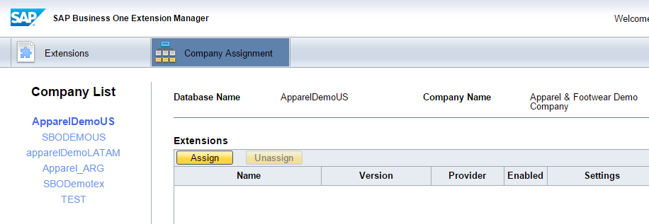

Select the solution and click next

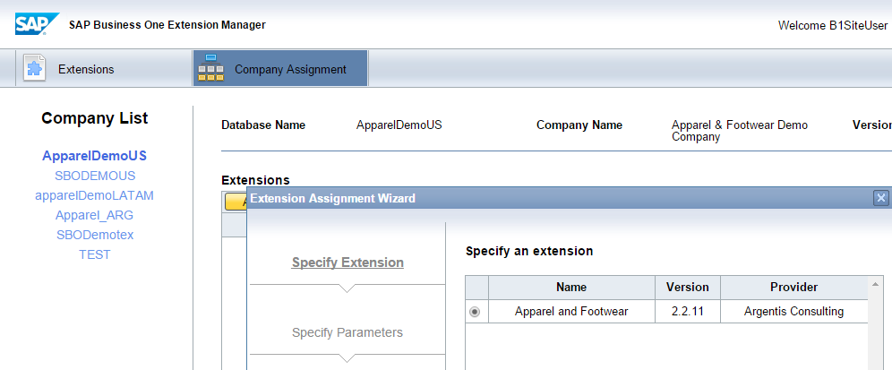

Assign the user defaults for startup mode

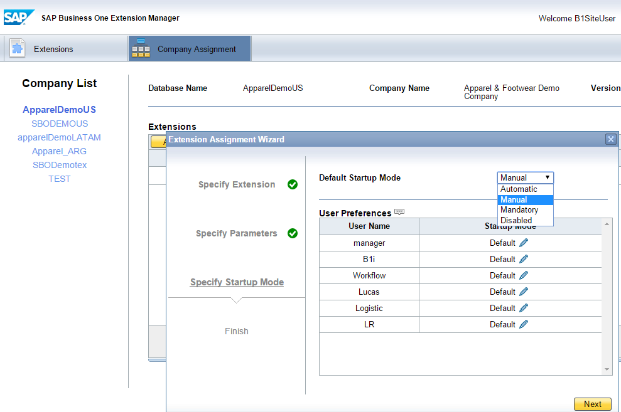

Login to the company and after a few seconds you will receive this message

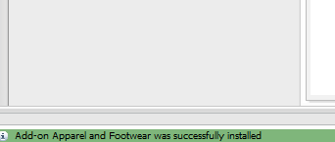

After the message the add on is available in the add on manager window

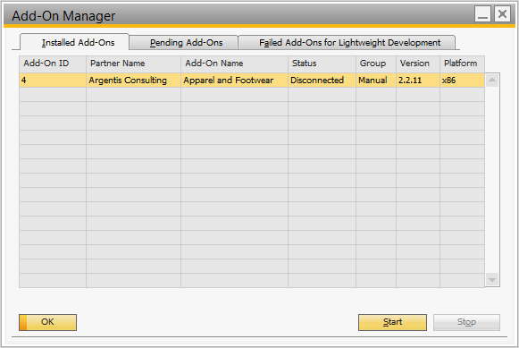

Now, follow the Maintenance steps.

## Uninstall and Unassign

### How to unassign it from the Company

To unassign the add on to the company select the solution and click on the Unassign option

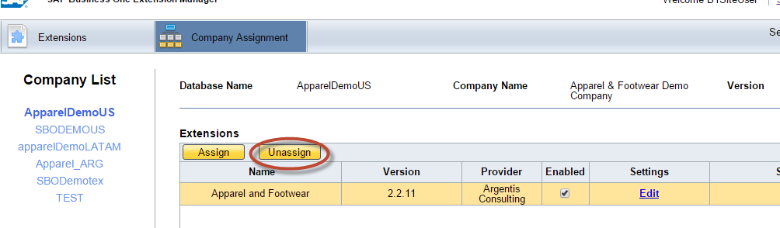

### How to uninstall it from the Server

To uninstall the Add On click on the Remove

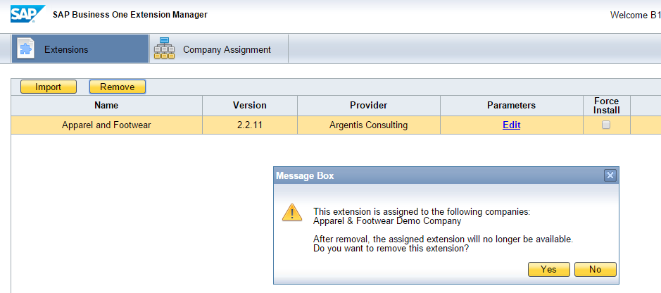

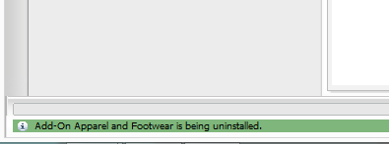

## Upgrade

To upgrade the Addon just simply click on import, browse for the .zip file and upload it.



The Addon will automatically be assigned to the companies it was assigned to in the previous version.

Now, follow the Maintenance steps.

## Maintenance

After installing or performing an upgrade of Apparel it is needed to run the Maintenance Module.

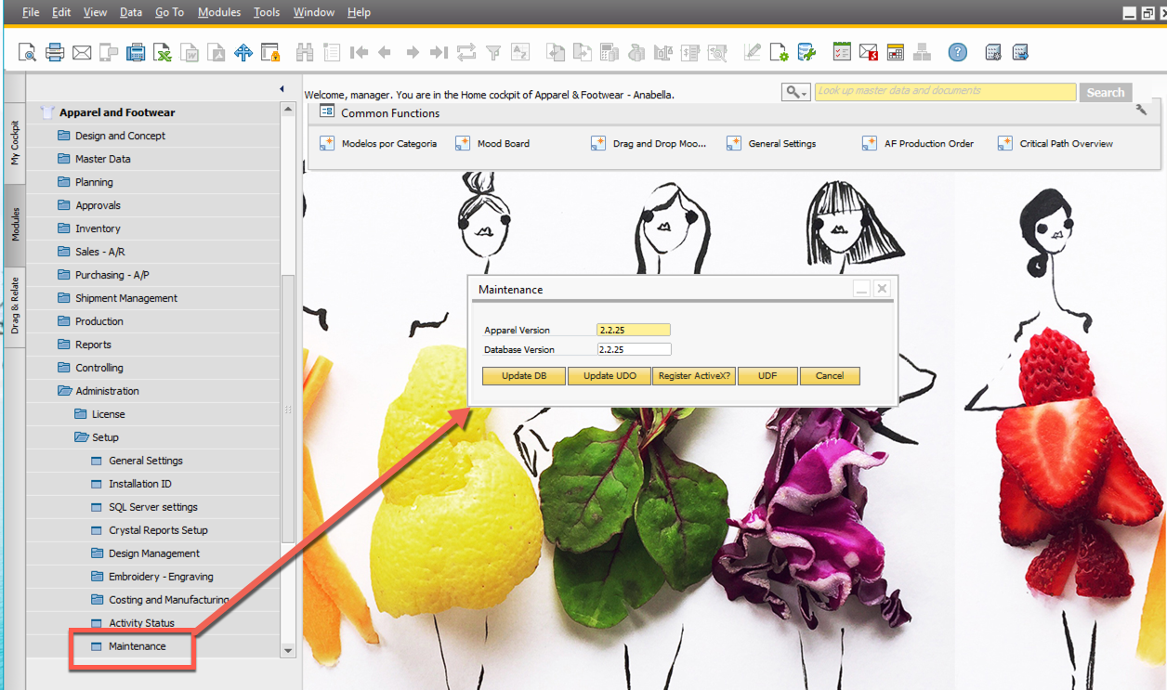

Perform the following steps in the following order in each Company the Addon was assigned to.

Click the button:

### In the Server Machine

1. Update DB
2. Update UDO

### In the Server and Client Machines

1. Register ActiveX



**www.argentisconsulting.com**

**Argentis Consulting** is dedicated to the development, distribution and support of recognized certified solutions for SAP Business One, as an SSP (Software Solution Provider) with a Gold Partner status.

**CONTACT INFORMATION**

|  |  |
| --- | --- |
| **USA**  9744 NW 45th Lane  Doral, FL 33178  info@argentisconsulting.com | **ARGENTINA**  Ávila y Zarate 2048  Cerro de la Rosas, Córdoba,  CP 5009  Córdoba - Argentina  info@argentisconsulting.com |
| **CARIBEAN**  City View Plaza – Suite 301  48 Road 165  Guaynabo, PR. 00968  Puerto Rico  caribe@argentisconsulting.com | **SPAIN**  C/ Juan Bravo N° 3 A 28006  Phone: (+34) 91 123 7263  Madrid - Spain  info@argentisconsulting.com |